Unit-2 (Database Programming)
A database is an organized collection of data. There are many different strategies for organizing data to facilitate easy access and manipulation. A database management System(DBMS) provides mechanisms for storing, organizing, retrieving and modifying data form any users. Database management systems allow for the access and storage of data without concern for the internal representation of data.
Today’s most popular database systems are relational databases.A language called SQL—pronounced “sequel,” or as its individual letters—is the international standard language used almost universally with relational databases to perform queries (i.e., to request information that satisfies given criteria) and to manipulate data. Some popular relational database management systems (RDBMSs) are Microsoft SQL Server, Oracle, Sybase, IBM DB2, Informix, PostgreSQL and MySQL. The JDK now comes with a pure-Java RDBMS called Java DB—Oracles’s version of Apache Derby.
Java programs communicate with databases and manipulate their data using the Java Database Connectivity (JDBC™) API. A JDBC driver enables Java applications to connect to a database in a particular DBMS and allows you to manipulate that database using the JDBC API.
What is JDBC?
The term JDBC stands for Java Database Connectivity. JDBC is a specification from Sun microsystems. JDBC is an API(Application programming interface) in Java that helps users to interact or communicate with various databases.
The classes and interfaces of JDBC API allow the application to send the request to the specified database.
Using JDBC, we can write programs required to access databases. JDBC and the database driver are capable of accessing databases and spreadsheets. JDBC API is also helpful in accessing the enterprise data stored in a relational database(RDB).
The JDBC API is a Java API that can access any kind of tabular data, especially data stored in a Relational Database. JDBC helps to write Java applications that manage these three programming activities:
- Connect to a data source, like a database
- Send queries and update statements to the database
- Retrieve and process the results received from the database in answer to your query

Applications of JDBC
JDBC is fundamentally a specification that provides a complete set of interfaces. These interfaces allow for portable access to an underlying database.
We can use Java to write different types of executables, such as:
- Java Applications
- Java Applets
- Enterprise JavaBeans (EJBs)
- Java Servlets
- Java ServerPages (JSPs)
Components of JDBC
1. JDBC API: JDBC API provides various interfaces and methods to establish easy connection with different databases.
javax.sql.*;
java.sql.*;

2. JDBC Driver Manager: The Driver Manager of JDBC loads database-specific drivers in an application. This driver manager establishes a connection with a database. It also makes a database-specific call to the database so that it can process the user request.
3. JDBC Test suite: JDBC Test suite facilitates the programmer to test the various operations such as deletion, updation, insertion that are being executed by the JDBC Drivers.
4. JDBC-ODBC Bridge Drivers: JDBC-ODBC Bridge Drivers are used to connect the database drivers to the database. The bridge does the translation of the JDBC method calls into the ODBC method call. It makes the usage of the sun.jdbc.odbc package that encompasses the native library in order to access the ODBC (Open Database Connectivity) characteristics.

Architecture of JDBC
The following figure shows the JDBC architecture:
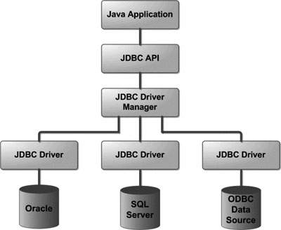

1) Application: It is the Java Servelet or an applet that communicates with the data source.
2) The JDBC API: It allows the Java Programs to perform the execution of the SQL statements and then get the results.
A few of the crucial interfaces and classes defined in the JDBC API are the following:
- Drivers
- DriverManager
- Statement
- Connection
- CallableStatement
- PreparedStatement
- ResultSet
- SQL data

- DriverManager − This class manages a list of database drivers. Matches connection requests from the java application with the proper database driver using communication sub protocol. The first driver that recognizes a certain subprotocol under JDBC will be used to establish a database Connection.
- Driver − This interface handles the communications with the database server. You will interact directly with Driver objects very rarely. Instead, you use DriverManager objects, which manages objects of this type. It also abstracts the details associated with working with Driver objects.
- Connection − This interface with all methods for contacting a database. The connection object represents communication context, i.e., all communication with database is through connection object only.
- Statement − You use objects created from this interface to submit the SQL statements to the database. Some derived interfaces accept parameters in addition to executing stored procedures.
- ResultSet − These objects hold data retrieved from a database after you execute an SQL query using Statement objects. It acts as an iterator to allow you to move through its data.
- SQLException − This class handles any errors that occur in a database application.
3) DriverManager: DriverManager plays a crucial role in the architecture of JDBC.
It uses database-specific drivers to connect the enterprise applications to various databases.
4) JDBC drivers: To interact with a data source with the help of the JDBC, one needs a JDBC driver which conveniently interacts with the respective data source.

JDBC Driver Types JDBC drivers are classified into the following types:
JDBC Driver is a software component that enables java application to interact with the database. There are 4 types of JDBC drivers:
- JDBC-ODBC bridge driver(Type1)
- Native-API driver (partially java driver)Type 2
- Network Protocol driver (fully java driver) Type3
- Thin driver (fully java driver) Type4
1) JDBC-ODBC bridge driver
The JDBC-ODBC bridge driver uses ODBC driver to connect to the database. The JDBC-ODBC bridge driver converts JDBC method calls into the ODBC function calls. This is now discouraged because of thin driver.
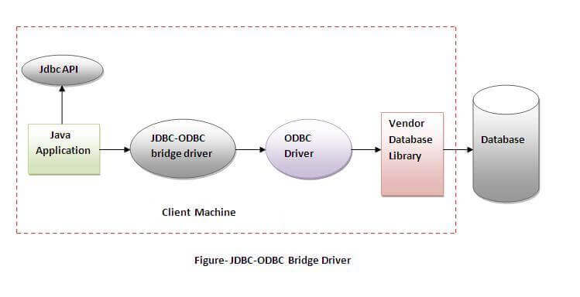
Oracle does not support the JDBC-ODBC Bridge from Java 8. Oracle recommends that you use JDBC drivers provided by the vendor of your database instead of the JDBC-ODBC Bridge.
Advantages:
easy to use.
can be easily connected to any database.
Disadvantages:
Performance degraded because JDBC method call is converted into the ODBC function calls.
The ODBC driver needs to be installed on the client machine.
2) Native-API driver
The Native API driver uses the client-side libraries of the database. The driver converts JDBC method calls into native calls of the database API. It is not written entirely in java.
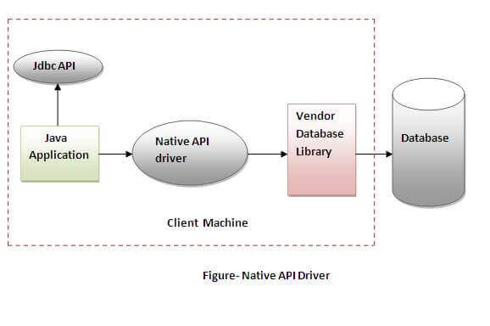
Advantage:
performance upgraded than JDBC-ODBC bridge driver.
Disadvantage:
The Native driver needs to be installed on the each client machine.

3) Network Protocol driver
The Network Protocol driver uses middleware (application server) that converts JDBC calls directly or indirectly into the vendor-specific database protocol. It is fully written in java.
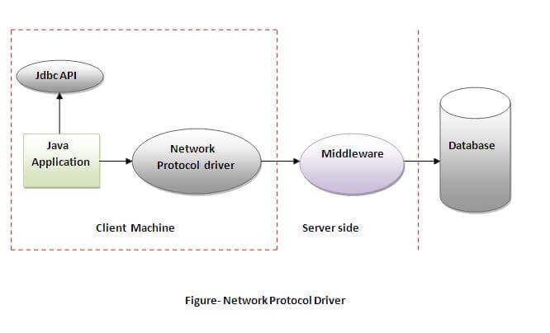
Advantage:
No client side library is required because of application server that can perform many tasks like auditing, load balancing, logging etc.
Disadvantages:
Network support is required on client machine.
Requires database-specific coding to be done in the middle tier.
4) Thin driver
The thin driver converts JDBC calls directly into the vendor-specific database protocol. That is why it is known as thin driver. It is fully written in Java language.
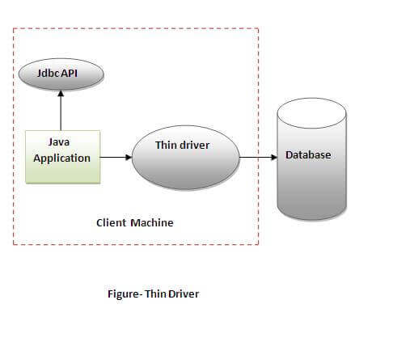
Advantage:
Better performance than all other drivers.
No software is required at client side or server side.
Disadvantage:
Drivers depend on the Database.

Advantages of Using JDBC
- It is capable of reading any database. The only requirement for it to do so is the proper installation of all the drivers.
- It automatically creates the XML format of data from the database.
- It does not require the content to be converted.
- It provides full support to query and stored procedure.
- It provides support to both Synchronous and Asynchronous processing.
- It supports modules

Steps For Connectivity Between Java Program and Database
- Import the Packages
- Load the drivers using the forName() method
- Register the drivers using DriverManager
- Establish a connection using the Connection class object
- Create a statement
- Execute the query
- Close the connections

Let us discuss these steps in brief before implementing by writing suitable code to illustrate connectivity steps for JDBC/
- Step 1: Import the Packages
- Step 2: Loading the drivers
In order to begin with, you first need to load the driver or register it before using it in the program. Registration is to be done once in your program. You can register a driver in one of two ways mentioned below as follows:

- Import Packages
First, we need to import the existing packages to use it in our Java program. Import will make sure that JDBC API classes are available for the program. We can then use the classes and subclasses of the packages.
Irrespective of the JDBC Driver, add the following import statement in the Java program.

import java.sql.*;
Import the other classes based on the functionality which you will use in the program. Download the appropriate Jar files for the database

JDBC API 4.0 mainly provides 2 important packages:
- java.sql
- javax.sql

Load Driver
First, we should load/register the driver in the program before connecting to the Database. You need to register it only once per database in the program.
We can load the driver in the following 2 ways:
- Class.forName()
- DriverManager.registerDriver()
Class.forName()
In this way, the driver’s class file loads into the memory at runtime. It implicitly loads the driver. While loading, the driver will register with JDBC automatically.
DB Name | JDBC Driver Name
MySQL | com.mysql.jdbc.Driver
Oracle | oracle.jdbc.driver.OracleDriver
Microsoft SQL Server | com.microsoft.sqlserver.jdbc.SQLServerDriver
MS Access | net.ucanaccess.jdbc.UcanaccessDriver
PostgreSQL | org.postgresql.Driver
IBM DB2 | com.ibm.db2.jdbc.net.DB2Driver
Sybase | com.sybase.jdbcSybDriver
TeraData | com.teradata.jdbc.TeraDriver

DriverManager.registerDriver()
DriverManager is an inbuilt class that is available in the java.sql package. It acts as a mediator between Java application and database which you want to connect. Before you connect with the database, you need to register the driver with DriverManager. The main function of DriverManager is to load the driver class of the Database and create a connection with DB.
Public static void registerDriver(driver) – This method will register the driver with the Driver Manager. If the driver is already registered, then it won’t take any action.
- It will throw SQLException if the database error occurs.
- It will throw NullPointerException if the driver is null.

DriverManager.registerDriver(new oracle.jdbc.driver.OracleDriver())
DriverManager.registerDriver(new com.microsoft.sqlserver.jdbc.SQLServerDriver())

3) Establish Connection
After loading the driver, the next step is to create and establish the connection. Once required, packages are imported and drivers are loaded and registered, then we can go for establishing a Database connection.
DriverManager class has the getConnection method, we will use this method to get the connection with Database. To call getConnection() method, we need to pass 3 parameters. The 3 parameters are string data type URL, a username, and a password to access the database.
The getConnection() method is an overloaded method. The 2 methods are:
- getConnection(URL,username,password); – It has 3 parameters URL, username, password.
- getConnection(URL); – It has only one parameter. URL has a username and password also.

The following table lists the JDBC connection strings for the different databases:
Database | Connection String/DB URL
MySQL | jdbc:mysql://HOST_NAME:PORT/DATABASE_NAME
Oracle | jdbc:oracle:thin:@HOST_NAME:PORT:SERVICE_NAME
Microsoft SQL Server | jdbc:sqlserver://HOST_NAME:PORT;DatabaseName=< DATABASE_NAME>
MS Access | jdbc:ucanaccess://DATABASE_PATH
PostgreSQL | jdbc:postgresql://HOST_NAME:PORT/DATABASE_NAME
IBM DB2 | jdbc:db2://HOSTNAME:PORT/DATABASE_NAME
Sybase | jdbc:Sybase:Tds:HOSTNAME:PORT/DATABASE_NAME
TeraData | jdbc:teradata://HOSTNAME/database=< DATABASE_NAME>,tmode=ANSI,charset=UTF8

4) Create And Execute Statement
Now we will create the statement object that runs the query with the connected database. We use the createStatement method of the Connection class to create the query.

(i) Create Statement
a)Statement
This interface is used to implement simple SQL statements with no parameter. It returns the ResultSet object.
- Statement statemnt1 = conn.createStatement();
b) PreparedStatement
It is used to implement parameterized and precompiled SQL statements. The performance of the application increases because it compiles the query only once.
String select_query = “Select * from states where state_id = 1”;
PreparedStatement prpstmt = conn.prepareStatement(select_query);
c) CallableStatement
It is used to implement a parameterized SQL statement that invokes procedure or function in the database. A stored procedure works like a method or function in a class.
CallableStatementcallStmt = con.prepareCall("{call procedures(?,?)}");

(ii) Execute The Query
There are 4 important methods to execute the query in Statement interface. These are explained below:
- ResultSet executeQuery(String sql)
- int executeUpdate(String sql)
- boolean execute(String sql)
- int []executeBatch()
a) ResultSet executeQuery(String sql)
The executeQuery() method in Statement interface is used to execute the SQL query and retrieve the values from DB. It returns the ResultSet object. Normally, we will use this method for the SELECT query.
b) executeUpdate(String sql)
The executeUpdate() method is used to execute value specified queries like INSERT, UPDATE, DELETE (DML statements), or DDL statements that return nothing. Mostly, we will use this method for inserting and updating.
c) execute(String sql)
The execute() method is used to execute the SQL query. It returns true if it executes the SELECT query. And, it returns false if it executes INSERT or UPDATE query.
d) executeBatch()
This method is used to execute a batch of SQL queries to the Database and if all the queries get executed successfully, it returns an array of update counts. We will use this method to insert/update the bulk of records.

5) Retrieve Results
When we execute the queries using the executeQuery() method, the result will be stored in the ResultSet object. The returned ResultSet object will never be null even if there is no matching record in the table. ResultSet object is used to access the data retrieved from the Database.
ResultSet rs 1= statemnt1.executeQuery(QUERY));

6)Close Connection
conn.close();

Question: 1 How do you execute SQL queries in JDBC
Ans:
To process an SQL statement, you need to follow the steps given below:
- Establish the connection.
- Create a statement.
- Execute the statement/query.
- Process the result.
- Close the connection.
1. Establishing a Connection
To process SQL statements first of all you need to establish connection with the desired DBMS or, file System or, other data sources.
- To do so, Register the JDBC driver class, corresponding to the DataSource you need to the DriverManager using the registerDriver() method.
Driver myDriver = new com.mysql.jdbc.Driver();
DriverManager.registerDriver(myDriver);

You can also register the driver using the forName() method. This method loads the specified class in to the memory and it automatically gets registered.
Class.forName("com.mysql.jdbc.Driver");
After registering the Driver class, get the Connection object using the getConnection() method.
This method accepts a database URL (an address that points to your database), Username and, password and, returns a connection object.
Connection con=DriverManager.getConnection("jdbc:mysql://localhost:3306/collegedb?useSSL=false","root","root");

2.Creating a Statement
The Statement interface represents an SQL statement and JDBC provides 3 kinds of Statements
- Statement: A general purpose statement which does not accept any parameters.
- PreparedStatement: A precompiled SQL statement which accepts input parameters.
- Callable Statement: This is used to call the stored procedures.

conn.createStatement();
conn.prepareStatement(query);
conn.prepareCall(query)
3.Executing the Statements
After creating the statement objects, you need to execute them. To execute the statements, the Statement interface provides three methods namely, execute(), executeUpdate() and, executeQuery().
- execute(): Used to execute SQL DDL statements, it returns a boolean value specifying whether the ResultSet object can be retrieved.
- executeUpdate(): Used to execute statements such as insert, update, delete. It returns an integer value representing the number of rows affected.
- executeQuery(): Used to execute statements that returns tabular data (example select). It returns an object of the class ResultSet.
stmt.execute(query);
stmt.executeQuery(query);
stmt.execute(query);
4. Processing the Result
Once you execute the statements/queries you will get the result of the respective query as a return value from execute() (boolean value) or, executeQuery() (ResultSet) or, executeUpdate() (integer value) methods.

while(rs.next())
System.out.println(rs.getInt(1)+" "+rs.getString(2)+" "+rs.getString(3));
con.close();
}

5.Close Connection
conn.close();
Connection with MySqlDatabase Example
DML Operation in JAVA
Executing Select Statement
import java.sql.*;
public class App {
public static void main(String[] args) throws Exception {
try {
Class.forName("com.mysql.jdbc.Driver");
Connection con=DriverManager.getConnection("jdbc:mysql://localhost:3306/collegedb?useSSL=false","root","root");

Statement stmt=con.createStatement();
ResultSet rs=stmt.executeQuery("select * from tblemployee");
while(rs.next())
System.out.println(rs.getInt(1)+" "+rs.getString(2)+" "+rs.getString(3));
con.close();
}
catch(Exception e){ System.out.println(e);}
}

}
Output:
1 Sunil Chaudhary Kathmandu
2 Bikash Shrestha Kathmandu
3 Dinesh Gautam Kathmandu
4 Hira Kahdma Kathmandu

Insert Statement
import java.sql.*;
public class App {

public static void main(String[] args) throws Exception {
try {

Class.forName("com.mysql.jdbc.Driver");
Connection con=DriverManager.getConnection("jdbc:mysql://localhost:3306/samriddhidb?useSSL=false","root","root");
String sql="insert into emp(ID,Name,Email,Address) values(?,?,?,?)";
PreparedStatement ps = con.prepareStatement(sql);
ps.setInt(1, 5);
ps.setString(2, "Suman");
ps.setString(3, "tony@gmail.com");
ps.setString(4, "Kathmandu");
ps.executeUpdate();
con.close();
System.out.println("Data Inserted");

}
catch(Exception e){ System.out.println(e);}
}

}

Update Statement
import java.sql.*;
public class App {

public static void main(String[] args) throws Exception {
try {

Class.forName("com.mysql.jdbc.Driver");
Connection con=DriverManager.getConnection("jdbc:mysql://localhost:3306/samriddhidb?useSSL=false","root","root");
String sql="update emp set email = ? where id = ?";
PreparedStatement ps = con.prepareStatement(sql);
ps.setInt(2, 5);
ps.setString(1, "suman@gmail.com");

ps.executeUpdate();
con.close();
System.out.println("Data Updated");

}
catch(Exception e){ System.out.println(e);}
}

}

Delete Statement
import java.sql.*;
public class App {

public static void main(String[] args) throws Exception {
try {

Class.forName("com.mysql.jdbc.Driver");
Connection con=DriverManager.getConnection("jdbc:mysql://localhost:3306/samriddhidb?useSSL=false","root","root");
String sql="delete from emp where id = ?";
PreparedStatement ps = con.prepareStatement(sql);
ps.setInt(1, 5);

ps.executeUpdate();
con.close();
System.out.println("Data Deleted");

}
catch(Exception e){ System.out.println(e);}
}

}

DDL Operation in JAVA
(Create,Alter,Drop,Truncate)
Data Definition Language (DDL) is a unique set of SQL commands that lets you manipulate the structure of the database.
CREATE Command
SQL Queries:
Create Database: CREATE DATABASE database_name;
Create Table:
CREATE TABLE table_name (
Column_1 data_type,
Column_2 data_type,
...
);

DROP Command
DROP is used to delete a whole database or just a table. The DROP statement destroys the objects like an existing database, table, index, or view. A DROP statement in SQL removes a component from a relational database management system (RDBMS)
Drop Database
DROP DATABASE database_name;
The syntax to DROP a table from the database is as follow,
Drop Table
DROP TABLE table_name;

The ALTER Command
when the data exists in the table(s) of our database, modifying the structure is easier through other means, such as ALTER is used to add, change, or remove columns or fields in the table. It can also be used to rename the table.
- Adding column(s)
- Modifying column(s)
- Removing columns

Add Column:
ALTER TABLE table_name ADD COLUMN column_name_1 data_type, column_name_2 data_type;
Modify Column:
ALTER TABLE table_name MODIFY COLUMN column_name data_type;
Remove a Column:
ALTER TABLE table_name DROP COLUMN column_name;

The RENAME Command
The RENAME command is used to change the name of an existing database object (like Table, Column) to a new name. Renaming a table does not make it lose any data that is contained within it.
RENAME TABLE current_table_name TO new_table_name;
TRUNCATE TABLE
The TRUNCATE TABLE command deletes the data inside a table, but not the table itself.
The following SQL truncates the table "Categories":
TRUNCATE TABLE Categories;
Write a java program to create database name collegemgmtdb.
CREATE DATABSE JAVA CODE
import java.sql.*;
public class App {
public static void main(String[] args) throws Exception {
try {
String Database_Name="NEW_DB";
Class.forName("com.mysql.jdbc.Driver");
Connection con=DriverManager.getConnection("jdbc:mysql://localhost:3306/samriddhidb?useSSL=false","root","root");
Statement st=con.createStatement();
String sql="CREATE DATABASE "+Database_Name;
st.executeUpdate(sql);
con.close();
System.out.println("Database Created");
}
catch(Exception e){ System.out.println(e);}
}

}

Creating Table:
import java.sql.*;
public class App {
public static void main(String[] args) throws Exception {
try {
String Table_name="CREATE TABLE Persons (PersonID int,LastName varchar(255));";
Class.forName("com.mysql.jdbc.Driver");
Connection con=DriverManager.getConnection("jdbc:mysql://localhost:3306/samriddhidb?useSSL=false","root","root");
Statement st=con.createStatement();
String sql=Table_name;
st.executeUpdate(sql);
con.close();
System.out.println("Table Created");
}
catch(Exception e){ System.out.println(e);}
}

}

Preapred Statement:

A PreparedStatement is a pre-compiled SQL statement. It is a subinterface of Statement. Prepared Statement objects have some useful additional features than Statement objects. Instead of hard coding queries, PreparedStatement object provides a feature to execute a parameterized query.
When PreparedStatement is created, the SQL query is passed as a parameter. This Prepared Statement contains a pre-compiled SQL query, so when the PreparedStatement is executed, DBMS can just run the query instead of first compiling it.

Steps to use PreparedStatement
- Create Connection to Database
Connection con=DriverManager.getConnection("jdbc:mysql://localhost:3306/samriddhidb?useSSL=false","root","root");

2. Prepare Statement
String sql="delete from emp where id = ?";
PreparedStatement ps = con.prepareStatement(sql);
3. Set parameter values for type and position
ps.setInt(2, 5);
ps.setString(1, "suman@gmail.com");

4. Execute the Query
ps.executeUpdate();

Methods of PreparedStatement:
- setInt(int, int): This method can be used to set integer value at the given parameter index.
- setString(int, string): This method can be used to set string value at the given parameter index.
- setFloat(int, float): This method can be used to set float value at the given parameter index.
- setDouble(int, double): This method can be used to set a double value at the given parameter index.
- executeUpdate(): This method can be used to create, drop, insert, update, delete etc. It returns int type.
- executeQuery(): It returns an instance of ResultSet when a select query is executed.

Lab: write a Java program to demonstrate multiple ResultSet in JDBC.
Multiple Result:
When working with inline SQL or SQL Server stored procedures that return more than one result set, the Microsoft JDBC Driver for SQL Server provides the getResultSet method in the class for retrieving each set of data returned.
To determine if more result sets are available, you can call the getMoreResults method, which returns a boolean value of true if more result sets are available.
import java.sql.*;
public class App {
public static void main(String[] args) throws Exception {

String sql="select * from tblstudent; select * from tblstudent;";
Class.forName("com.mysql.jdbc.Driver");
Connection con=DriverManager.getConnection("jdbc:mysql://localhost:3306/swastik_db?useSSL=false&allowMultiQueries=true","root","root");
Statement st=con.createStatement();
boolean results = st.execute(sql);
int rsCount = 0;
do {
if(results) {
ResultSet rs = st.getResultSet();
rsCount++;
//Show data from the result set.
System.out.println("RESULT SET #" + rsCount);
while (rs.next()) {
System.out.println(rs.getString("Name") + ", " + rs.getString("Address"));
}
rs.close();
}
System.out.println();
results = st.getMoreResults();
} while(results);
st.close();
}

}

Scrollable ResultSet
Let’s first make the ResultSet object scrollable. Scrollable means that once the ResultSet object has been created, we can traverse through fetched records in any direction, forward and backward, as we like. This provides the ability to read the last record, first record, next record, and the previous record.
Scroll type constant
There are 3 scroll type constants can be used with ResultSets.
ResultSet.TYPE_FORWARD_ONLY
Default type.. only allows forward only fetching
ResultSet.TYPE_SCROLL_INSENSITIVE
Allows both forward and backward movement. Not sensitive to ResultSet updates.
ResultSet.TYPE_SCROLL_SENSITIVE
Syntax :
PreparedStatement pstmt = conn.prepareStatement(sql,Scroll type constant,Concurrency constant);
Statement stmt = conn.createStatement(Scroll type constant,Concurrency constant);

Allows both forward and backward movement. Not sensitive to ResultSet updates.
Concurrency constant
We can use following Concurrency constants for the ResultSets.
ResultSet.CONCUR_READ_ONLY
Default value .. ResultSet can not be updated.
ResultSet.CONCUR_UPDATABLE
Signifies an updatable ResultSet.

Example:
Statement stmt = con.createStatement(ResultSet.TYPE_SCROLL_INSENSITIVE,
ResultSet.CONCUR_UPDATABLE);
PreparedStatement pstmt = conn.prepareStatement(sql,ResultSet.TYPE_SCROLL_INSENSITIVE, ResultSet.CONCUR_READ_ONLY);
Lab: Write a java program to demonstrate Scrollable ResultSet
In JDBC.
Example:
import java.sql.*;
public class App {
public static void main(String[] args) throws Exception {
try {
String sql="select * from emp";
Class.forName("com.mysql.jdbc.Driver");
Connection con=DriverManager.getConnection("jdbc:mysql://localhost:3306/samriddhidb?useSSL=false","root","root");

PreparedStatement pstmt = con.prepareStatement(sql,ResultSet.TYPE_SCROLL_INSENSITIVE,ResultSet.CONCUR_READ_ONLY);
ResultSet rs = pstmt.executeQuery();
//First Record
rs.first();
System.out.println("ID : " + rs.getInt("id") + ", Name : " + rs.getString("name") + ", Email : " + rs.getString("Email"));

//Last Record
rs.last();
System.out.println("ID : " + rs.getInt("id") + ", Name : " + rs.getString("name") + ", Email : " + rs.getString("Email"));

//Previous Record
rs.previous();
System.out.println("ID : " + rs.getInt("id") + ", Name : " + rs.getString("name") + ", Email : " + rs.getString("Email"));

//Next Record
rs.next();
System.out.println("ID : " + rs.getInt("id") + ", Name : " + rs.getString("name") + ", Email : " + rs.getString("Email"));
}
catch(Exception e){ System.out.println(e);}
}

}

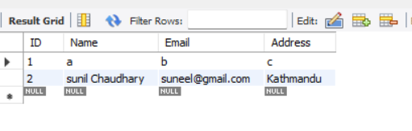
Output:
ID : 1, Name : a, Email : b
ID : 2, Name : sunil Chaudhary, Email : suneel@gmail.com
ID : 1, Name : a, Email : b
ID : 2, Name : sunil Chaudhary, Email : suneel@gmail.com

Updatable ResultSet:
Creating an updatable ResultSet means that the record it points to is not only be traversable but also be updatable. The changes will immediately be persisted in the database and reflected by the ResultSet object in real time.
import java.sql.*;
public class App {
public static void main(String[] args) throws Exception {
try {
String sql="select * from emp where id=?";
Class.forName("com.mysql.jdbc.Driver");
Connection con=DriverManager.getConnection("jdbc:mysql://localhost:3306/samriddhidb?useSSL=false","root","root");
PreparedStatement pstmt = con.prepareStatement(sql,ResultSet.TYPE_SCROLL_SENSITIVE,ResultSet.CONCUR_UPDATABLE);
pstmt.setInt(1,1);
ResultSet rs = pstmt.executeQuery();
while(rs.next())
{
System.out.println("ID : " + rs.getInt("id") + ", Name : " + rs.getString("name") + ", Email : " + rs.getString("Email"));
String name=rs.getString("name");
System.out.println("Updating name "+name+" to Subham");
rs.updateString("name", "Subham");
rs.updateRow();
}

}
catch(Exception e){ System.out.println(e);}
}

}

The updatable ResultSet is particularly useful when we want to update certain values after doing some comparison by traversing back and forth through the fetched records. The process of creation is similar to the preceding program, but the ResultSet constants used here are TYPE_SCROLL_SENSITIVE and CONCUR_UPDATABLE.

RowSet:
A row set is an object which encapsulates a set of rows. These rows are accessible though the javax.sql.RowSet interface.

Three kinds of row set are supported by Java:
- Cached row set
- JDBC row set
- Web row set
A JDBC RowSet facilitates a mechanism to keep the data in tabular form. It happens to make the data more flexible as well as easier as compared to a ResultSet. The connection between the data source and the RowSet object is maintained throughout its life cycle. The RowSet supports development models that are component-based such as JavaBeans
Example:
JdbcRowSet rowSet = RowSetProvider.newFactory().createJdbcRowSet();
rowSet.setUrl("jdbc:oracle:thin:@localhost:1521:xe");
rowSet.setUsername("root");
rowSet.setPassword("root");

rowSet.setCommand("select * from emp400");
rowSet.execute();

Advantage of RowSet
The advantages of using RowSet are given below:
- It is easy and flexible to use.
- It is Scrollable and Updatable by default.

import javax.sql.rowset.JdbcRowSet;
import javax.sql.rowset.RowSetProvider;
public class App {
public static void main(String[] args) throws Exception {
try {
JdbcRowSet rowSet = RowSetProvider.newFactory().createJdbcRowSet();
rowSet.setUrl("jdbc:mysql://localhost:3306/samriddhidb?useSSL=false");
rowSet.setUsername("root");
rowSet.setPassword("root");

rowSet.setCommand("select * from emp");
rowSet.execute();
while(rowSet.next())
{
System.out.println("ID : " + rowSet.getInt("id") + ", Name : " + rowSet.getString("name") + ", Email : " + rowSet.getString("Email"));

}

}
catch(Exception e){ System.out.println(e);}
}

}

